Week - 1

Program:
Output:

Program:
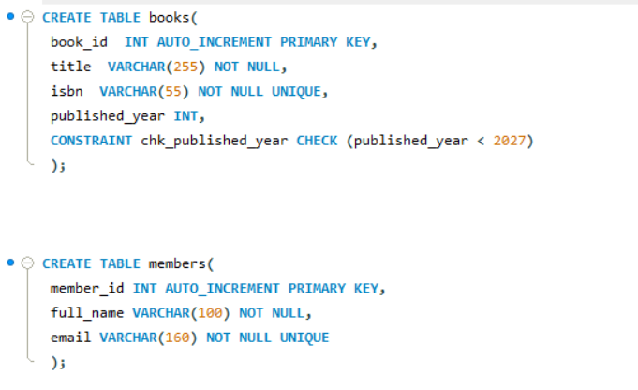
Output:

Program:
Output:
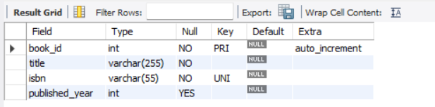
Program:
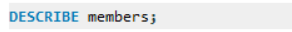
Output:
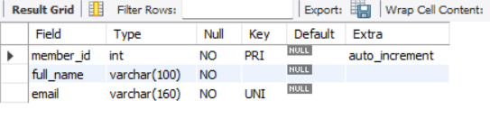

Program:
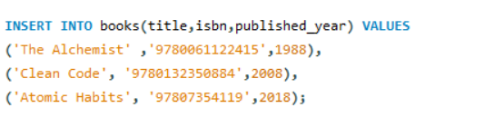
Output:

Program:
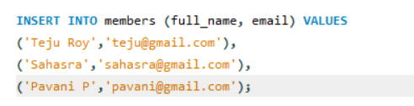
Output:

Program:
Output:
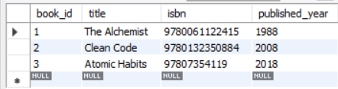

Program:
Output:
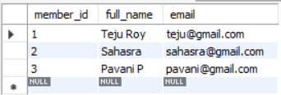
Program:
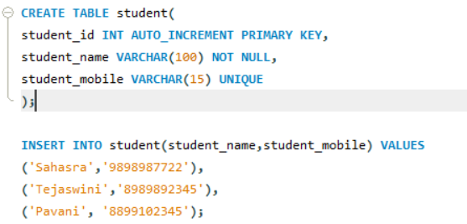
Output:

Program:
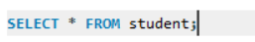
Output:
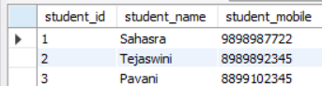

Student Marks:

Program:
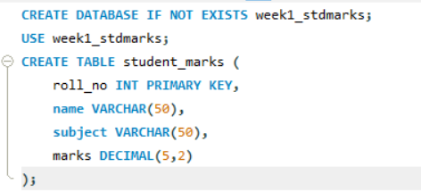
Output:
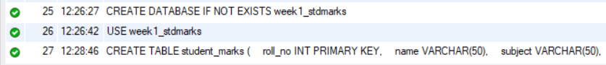
Program:
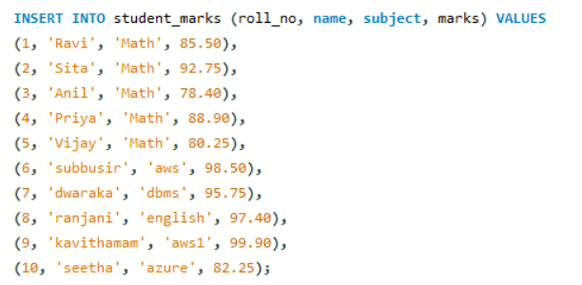
Output:

Program:
Output:
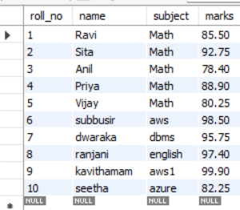
Program:
Output:
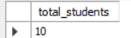
Program:
Output:
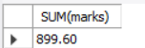
Program:
Output:
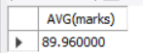
Program:
Output:
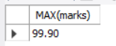

Program:
Output:
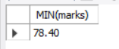
Program:
Output:
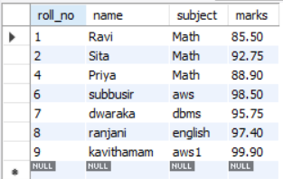
Program:
Output:
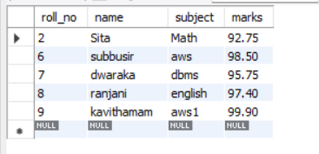
Program:
Output:
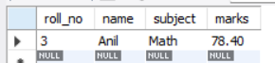

Program:
Output:
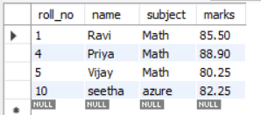
Program:
Output:
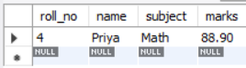
Program:
Output:
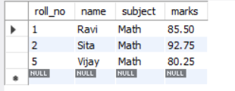
Program:
Output:
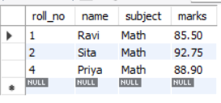

Program:
Output:
Program:
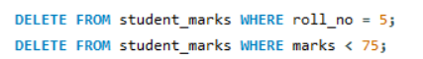
Output:
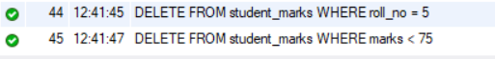
Program:
Output:
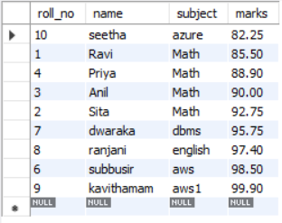

Program:
Output:
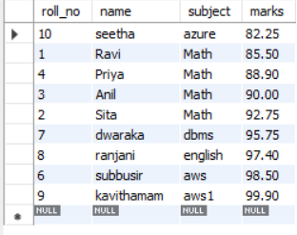
Program:
Output:
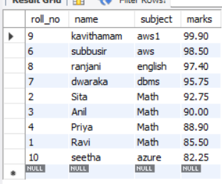

Program:
Output:
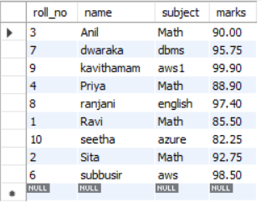
Program:
Output:
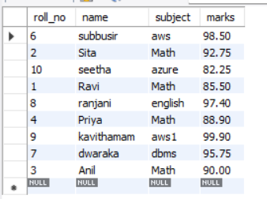
Program:
Output:
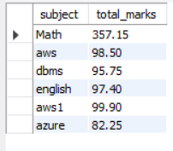
Program:
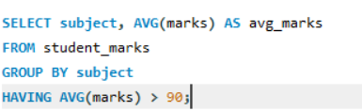
Output:
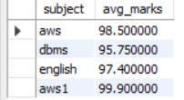
Program:
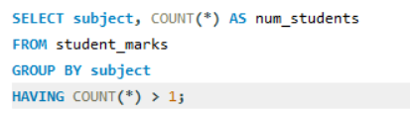
Output:
